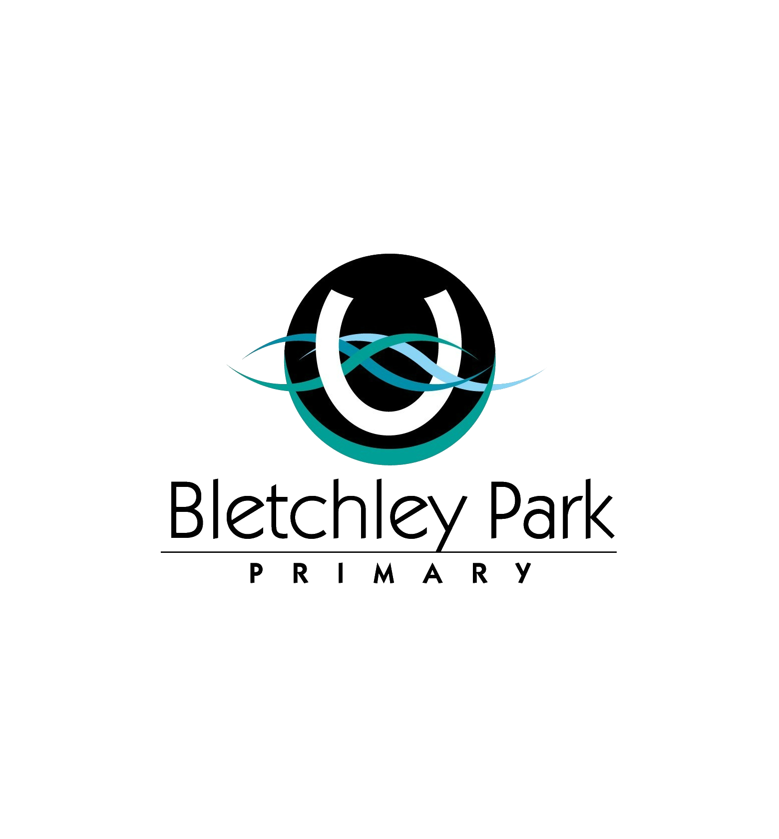

Annual Report

2017

AN INDEPENDENT PUBLIC SCHOOL

Our Context

Bletchley Park Primary School is located in Southern River. It was established in 2008 with an initial enrolment of 190 students. The school has an ICSEA index of 1046 and has an ever changing demographic. Due to having an excellent reputation for delivering high quality teaching and learning programs, Bletchley Park has been the school of choice for many parents. The school has a dedicated School Board and a highly involved P & C Association.

**Enrolment Trends**

In 2017 we experienced continued growth in student numbers with 1056 students enrolled from K to Year 6.

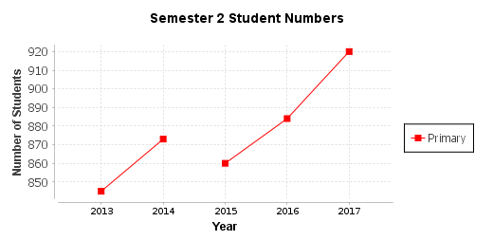

**Our Staff**

The Bletchley Park Primary teaching staff meet the professional requirements to teach in Western Australian public schools and hold current Working with Children Checks.

|  |  |  |  |  |  |  |  |  |  |  |  |  |  |  |  |  |  |  |  |  |  |  |  |  |  |  |  |  |  |  |  |  |  |  |  |  |  |  |  |  |  |  |  |  |  |  |  |  |  |  |  |  |  |  |  |  |  |  |  |  |  |  |  |  |  |  |  |  |  |  |  |  |  |  |  |  |
| --- | --- | --- | --- | --- | --- | --- | --- | --- | --- | --- | --- | --- | --- | --- | --- | --- | --- | --- | --- | --- | --- | --- | --- | --- | --- | --- | --- | --- | --- | --- | --- | --- | --- | --- | --- | --- | --- | --- | --- | --- | --- | --- | --- | --- | --- | --- | --- | --- | --- | --- | --- | --- | --- | --- | --- | --- | --- | --- | --- | --- | --- | --- | --- | --- | --- | --- | --- | --- | --- | --- | --- | --- | --- | --- | --- | --- |
| |  |  |  |  | | --- | --- | --- | --- | |  | No | FTE | AB'L | |  | | |  | | Administration Staff |  |  |  | | Principals | 1 | 1.0 | 0 | | Deputy Principals | 4 | 3.8 | 0 | | Total Administration Staff | 5 | 4.8 | 0 | |  | | |  | | Teaching Staff |  |  |  | | Level 3 Teachers | 7 | 6.2 | 0 | | Other Teaching Staff | 56 | 46.9 | 0 | | Total Teaching Staff | 63 | 53.1 | 0 | |  | | |  | | School Support Staff |  |  |  | | Clerical / Administrative | 8 | 5.2 | 0 | | Gardening / Maintenance | 2 | 0.9 | 0 | | Other Non-Teaching Staff | 31 | 26.4 | 1 | | Total School Support Staff | 41 | 32.5 | 1 | |  | | | | | Total | 109 | 90.4 | 1 | |

**Attendance**

There is evidence-based research indicating the strong link between attendance and educational outcomes. Bletchley Park Primary continues to monitor attendance with regular tracking of students at risk. Ongoing communication with parents is evident with a focus on working with families to improve attendance rates for at risk students. The school attendance rate again remained above Like and WA Public Schools in 2017.

|  |  |  |  |  |  |  |  |  |  |  |  |  |  |  |  |  |  |  |  |  |  |  |  |  |  |  |  |  |  |  |  |  |  |  |  |  |  |  |  |  |  |  |  |  |  |  |  |  |  |
| --- | --- | --- | --- | --- | --- | --- | --- | --- | --- | --- | --- | --- | --- | --- | --- | --- | --- | --- | --- | --- | --- | --- | --- | --- | --- | --- | --- | --- | --- | --- | --- | --- | --- | --- | --- | --- | --- | --- | --- | --- | --- | --- | --- | --- | --- | --- | --- | --- | --- |
| |  |  |  |  |  |  |  |  |  |  | | --- | --- | --- | --- | --- | --- | --- | --- | --- | --- | |  | Non - Aboriginal | | | Aboriginal | | | Total | | | | School | Like Schools | WA Public Schools | School | Like Schools | WA Public Schools | School | Like Schools | WA Public Schools | | 2015 | 94.1% | 94.0% | 93.8% | 93.2% | 86.9% | 81.2% | 94.0% | 93.7% | 92.7% | | 2016 | 94.3% | 94.1% | 93.7% | 95.6% | 88.4% | 80.7% | 94.3% | 93.9% | 92.6% | | 2017 | 94.4% | 94.4% | 93.8% | 94.1% | 89.2% | 81.2% | 94.4% | 94.3% | 92.7% | |

**Destination Schools for 2017**

At the end of 2017, 77% of our students who left Bletchley Park Primary School at the end of the year, attend WA public high schools in 2017. This is a significant increase from 2015.

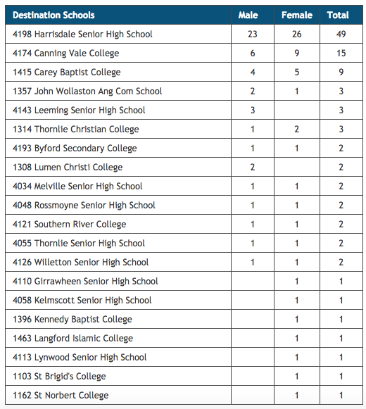

School Vision

*Bletchley Park Primary School is a nurturing community where*

*we can* ***be, think*** *and* ***grow****.*

**Be, think** and **grow** reflects the aspirations and core beliefs

of our school and its community. Our vision is the driving force

behind all decisions, policies and processes and is reflected in all aspects of the daily management and operations of our school. It is the key focus of teaching and learning programs, defines the physical environment to optimise student learning and fosters productive and sustainable relationships to enhance learning.

Our Beliefs

The beliefs of our school articulate the shared understanding of the school’s vision in operation. They describe the qualities of learning, describe our school in action and provide a framework for decision making and policy. The beliefs, school values and vision combine to enhance the school’s positive reputation and culture.

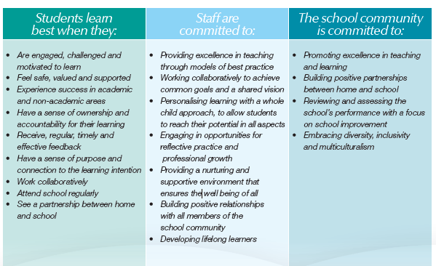

Our Values

Our school has two core values that underpin everything we do in the school

**Doing My Best**

I always do my best. I put in a good effort every day. I work well by myself and with other people.

**Respect**

I show respect for myself, other people and the environment.

Quality Teaching

A renewed and relentless focus on the best possible teaching practices.

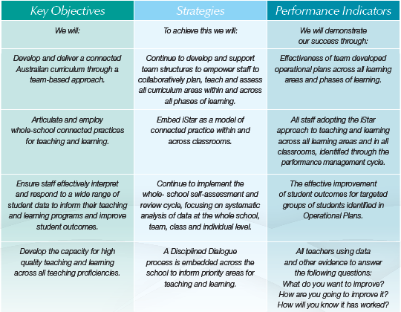

* Level 3 teachers were released for 0.2 FTE to take on the role of Curriculum Leaders with a focus on operational planning, connected practice and data analysis.
* iStar was revisited and planned to be embedded across learning areas.
* Rigorous analysis of student data is undertaken following the school audit process.
* Collaborative planning is undertaken fortnightly in teams to monitor student progress, classroom and whole school plans
* Talk4Writing further developed across all year levels.

Successful Students

High expectations of success for every student in the school.

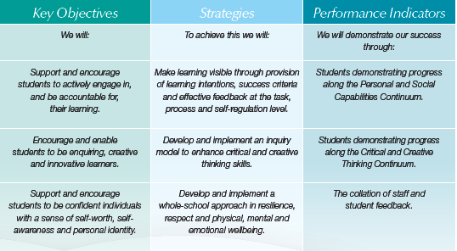

* Rigorous analysis of On Entry, NAPLAN and school assessment data is undertaken to inform teaching and learning programs
* Case management approach to students at educational risk has been adopted.

Effective Leadership

Strong and empowering leadership.

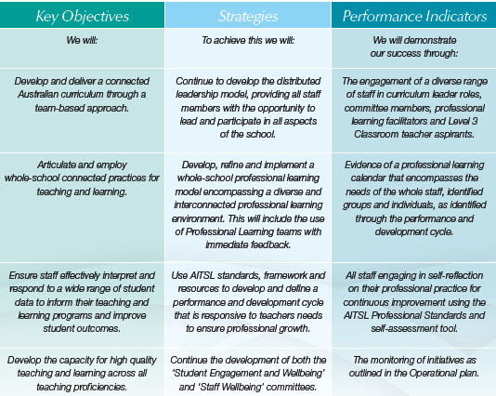

* Curriculum leaders continue to lead year level teams.
* Literacy and Numeracy Curriculum Consultants continued to work alongside teachers
* Performance and Development cycle reviewed and refined using AITSL Standards and Framework documents.
* Student and Staff Engagement and Wellbeing committee formed.

Connected Community

A capable and responsive organisation for now and into the future.

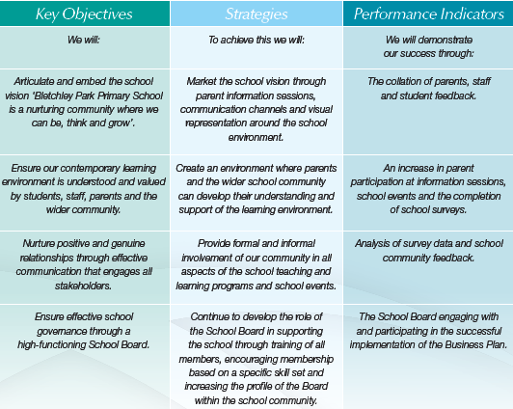

* Continued rebranding of the school to promote the school vision.
* Increased the use of Facebook and school website to communicate with parents.
* Used DOJO and seesaw as the key communication strategy between classroom teachers and their parent body.
* Introduced new induction process for Kindergarten students and parents.
* Utilised school survey results to respond to community feedback and ideas.
* School Board Terms of Reference, Code of Conduct and Induction file informed the Board’s operations.

Our Specialist Programs

Music

All students from Pre-primary to Year Six have the opportunity to learn Music at Bletchley Park Primary School. Our Music program is guided by the National Curriculum for Arts developed by the School Curriculum and Standards Authority. Students participate in a one hour music lesson each week, engaging in such activities as singing, reading music, playing instruments, composing music, learning about different music genres and reflecting on their musical experiences. In 2017 our Bletchley Park Choir performed at several events including the ANZAC Day service, assemblies, year 6 Graduation Ceremony, Presentation Evening and at the WAGSMS School Concert Night at the Crown Theatre. Bletchley Park Primary School is involved in the Instrumental Music Schools Services (IMSS) and offers tuition in guitar.

Physical Education

At Bletchley Park Primary School all students from PP to Year Six partake in physical education lessons with a specialist physical education teacher. Planning and learning are centred around the Western Australian Curriculum to ensure our students are developing and performing the appropiate skills for their age. Our school celebrated several achievements in 2017 included; 1st place in Interschool Athletics Carnival (back to back winners), 2nd Place in Interschool Cross Country Carnival, and Girls Football Dockers Cup Champions. . Our approach to physical education lessons and sport is of an inclusive nature to maximise participation and focus on student centred-learning. Bletchley Park Primary played a significant role in co-ordinatored the Bletchley Vale Cup Tournament, an annual interschool carnival initiated by the school in 2016, for our students with special educational needs. In 2017 3 schools joined the competition.

Science

Science is an essential part of everyday life. For students to achieve in Science, they need to acquire the necessary scientific knowledge, in order to answer scientific questions about the world around them. In 2017 Bletchley Park Primary School ran Science as a specialist program from Kindergarten to Year 6. All Science programs taught were aligned with the Western Australian Curriculum. This curriculum is delivered through inquiry-based learning that allows students to participate in hands on learning activities. The development of Science Inquiry Skills underpins all science teaching and learning programs at Bletchley Park Primary. National Science week saw students participate in a range of activities about Future Earth. Coding clubs have been established allowing students to experiment and develop their coding abilities. As a Water Wise accredited school, students participate in National Water week. Students engaged in a range of activities from collecting and recording data about the amount of water used around the school, to experiencing what it would be like to carry clean water long distances every day, like some children do in third world countries

English as an Additional Language or Dialect

The EAL/D program at Bletchley Park is designed to meet the needs of students from culturally and linguistically diverse backgrounds. A large component of the program focuses around oral and written language competence across the curriculum. There has been a significant increase in the percentage of EAL/D students at Bletchley Park Primary School. The school continued to employ an EAL/D Curriculum Consultant and 3 teaching staff in 2017 to work collaboratively with classroom teachers to plan, implement and evaluate appropriate programs to ensure teaching and learning needs of our students are met. A key objective in our Business Plan is *‘to ensure our contemporary learning environment is understood and valued by students, staff, parents and the wider community.’* Throughout 2017 our EAL/D team held regular EAL/D parent information sessions using interpreters to ensure our EAL/D parents have a good understanding of our programs. These programs were embraced by our EAL/D parents. Harmony Week is an important annual event at our school. In 2017 students embraced the theme of ‘Our diversity is our strength’ through participation in class activities and performances titled *‘Aboriginal Survival Technology’* and *‘Aboriginal Storytelling’*. The many members of our community joined us for a family picnic with everyone wearing the colours of harmony or traditional dress.

Learning Support

We have a rigorous approach to identifying students at educational risk. Staff use a varied range of data including NAPLAN, On Entry Assessment, Screen of Oral Communication Skills, Progress Achievement assessments and PM Benchmarking to identify students. A case management approach is used with these students. A learning support team consisting of members of the Leadership team, Curriculum Coordinators, Curriculum Consultants and School Psychologist work alongside classroom teachers to ensure effective planning and implentation of programs is embedded. The school employed 0.6 FTE in support teacher time and additional Education Assistants to provide support for classroom teachers to plan and implement teaching and learning programs, ensuring continued improvement for our identified students at educational risk. The school, continued to use SEN planning and reporting documents for these students. The school provided additional FTE for all Level 3 EAs to engage in planning time with teachers on a weekly basis. The school continued to run Life Skills, Super Flex, Clubs and the Incredible Flexible you programs.

ICT (Information and Communications Technology)

ICT continues to be a school focus for Bletchley Park Primary School. ICT is embedded in most learning areas where students are given opportunities to use ICT effectively to access, create and communicate ideas. Class teachers utilised Seesaw or DOJO in their classes as a means of communicating with parents on teaching and learning programs and student progress.

The STEM committee created a scope and sequence to include digital and design technologies.

Staff and Student Wellbeing

A key objective in our Business Plan is to *‘support and encourage students to be confident individuals with a sense of self-worth, self-awareness and personal identity.’* In 2017 a Staff and Student Wellbeing committee was formed and a key focus was on implementing the SDERA Challenges and Choices program. This program aims to develop students personal and social capabilities including making decisions, building resilience and positive relationships. Our pastoral care programs Drumbeat and Rainbows continued to run in 2017 and our School Chaplain continued to work with many of our students and families.

On Entry Assessment

The On Entry Assessment program provides teachers and parents with information about the understandings a child brings to school in pre-primary, Year 1 and Year 2. The assessment program provides information about the current skills the students are demonstrating in Speaking and Listening, Reading, Writing and Numeracy.

In 2017 all Pre-Primary, Year 1 and Year 2 students were administered the On Entry Assessment. The results assisted teachers with their planning of targeted teaching and learning programs. At BPPS we use this data as part of our school improvement process not only to identify students at educational risk; but also to measure ongoing progress of our students

**Progress Against Identified School Priorities (Business Plan)**

**Quality Teaching**

**Identified School Priorities**

1. Develop operational plans across learning teams and phases of learning
2. Whole school connected practices for teaching and learning
3. Staff respond to a range of student data to inform teaching and learning programmes and improve student outcomes
4. Employ a Disciplined Dialogue approach

**Progress/Achievement**

1. Initial Operational Plans for Literacy and Numeracy were developed and shared with staff as a starting point. Staff feedback and consultation was sought through a thorough review process at a team and whole school level. This led to a refinement process where plans were updates to reflect whole staff input. Targets were also reviewed using On-Entry and NAPLAN data from previous years. Curriculum Coordinators were trained in setting targets and this process is reflected in BPPS’s current operational targets.
2. A full scale review of BPPS’s approach to Numeracy was conducted; school Numeracy leaders attended Professional Learning through WAPPA (Leading an Effective Numeracy School). This led to the development of BPPS’s Whole School Numeracy plan which utilised the iStar model staff had previously been upskilled with. Numeracy foci such as vocabulary, the Numeracy block approach, a common problem solving process and a resource audit took place. Staff had the opportunity through the Numeracy committee and staff meetings to feedback on the plan; this plan was put in place in Term 4; a review of current assessment practices will follow in 2018. Talk 4 Writing also continued in the second year of its three-year-cycle. Initial findings indicate a positive result; the introduction of Brightpath as a whole school moderation tool will serve to strengthen the whole school connected practice in Writing.

**3/4**.Staff were engaged in a data analysis session of 2017 NAPLAN data. A Disciplined Dialogue approach was utilised and guiding questions provided to staff. Curriculum

Leaders led the session; they were given extra PL in terms of data analysis and Disciplined Dialogue. The information extracted by staff during this session was used to refine and update the school’s operational plans for 2018

**Spelling**

Spelling was a whole school priority in 2017; staff engaged in PL in the ‘Words Their Way’ programme and continued to implement this in Years 3-6. Students who required significant intervention were grouped and provided with the explicit ‘Letters and Sounds’ programme through the EA support timetable.

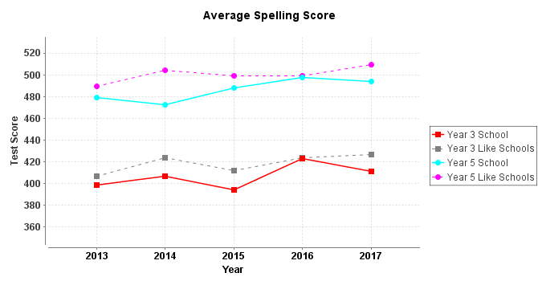

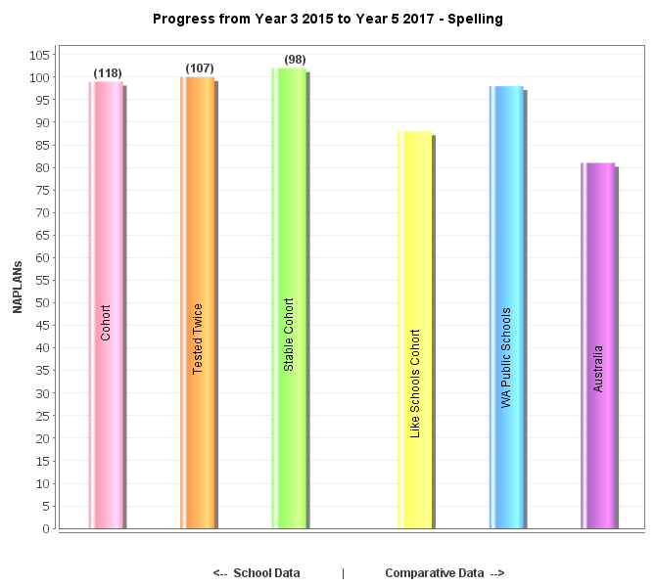

Year 5 Spelling results in 2017 were slightly above expected performance; however there was not the expected lift in overall performance.

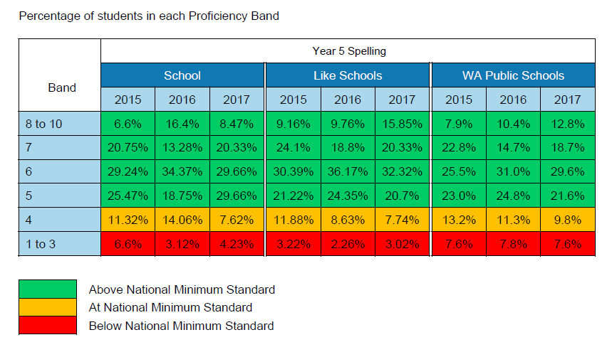

Early Childhood students continued with Letters and Sounds; a synthetic, direct instruction phonics programme. Students who did not meet the benchmarks were organised into early intervention groups for target instruction. Letters and Sounds tracking booklets were used to monitor progress and identity further students who required early intervention. This information was added to a handover sheet to ensure a smooth transition.

Decodable readers were introduced to build fluency and practise letter/sound knowledge at an individual level. This complements the Letters and Sounds programme.

The introduction of the explicit teaching of vocabulary to build language comprehension was a focus in 2017.

Mini-Lit (Years 1&2) and Maq Lit (Year 4) were introduced. These targeted intervention programmes were introduced to cater for our Students at Educational Risk and EAL/D students.

**School Based Targets**

**NAPLAN 2017**

Early stage operational targets were set against previous years’ NAPLAN achievement. 2017 NAPAN data indicates some areas requiring further investigation and attention; targets have since been revised utilising current longitudinal data and a review of current practices and pedagogy commenced.

* NAPLAN Progress – we have consistently added value to our students; we outperformed ‘like’ schools in all areas.
* EALD – our EALD students have achieved and progressed well across the board.
* Year 3 girls are considerably outperforming Year 3 boys in Literacy.

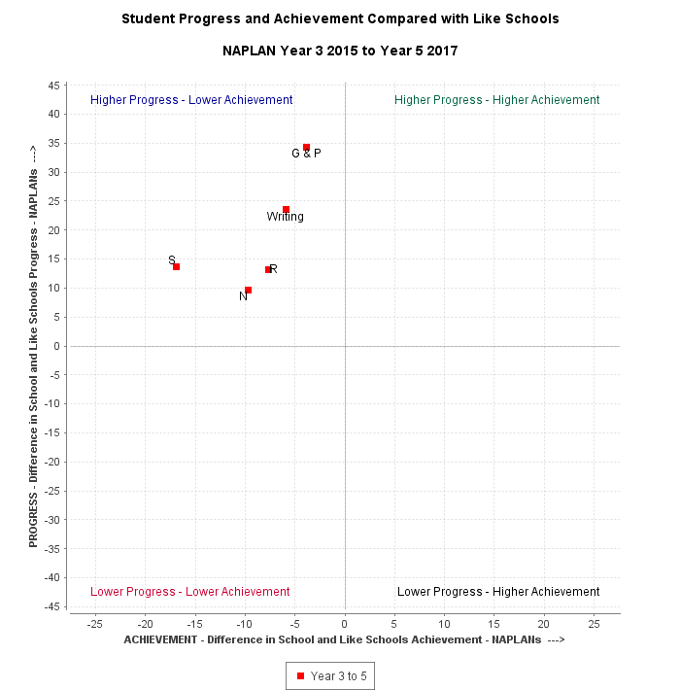

***Reading***

* For 2017 reduce by 1.5% the number of **Year 3** students in bands 1-3.
* For 2017 reduce by 1.5% the number of **Year 5** students in Bands 1-.4

***Writing***

* *Currently we have 18% of* ***Year 3*** *students in Band 6+ and 46% in Band 5.*
* By 2018 we will see an increase of 7% to 25% in Band 6*+*
* *Currently we have 8% of* ***Year 5*** *students in Band 8+ and 33% in Band 5.*
* By 2018 we will see an increase of 7% to 15% in Band 8+ and a further increase in Band 7 from 16% to 25%.
* By 2018 we will see a decrease of **Year 5** students at minimum standard and below from 15% to 10%.

***Numeracy***

* For 2017 reduce by 3% the number of **Year 3** students in Bands 1-3.
* For 2017 reduce by 3% the number of **Year 5** students in Band 4.

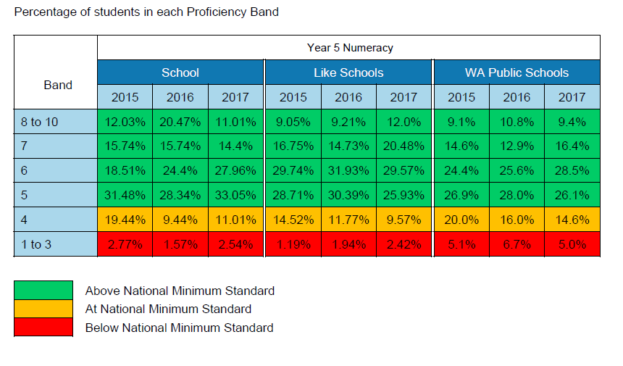

Targets not achieved are indicated in red.

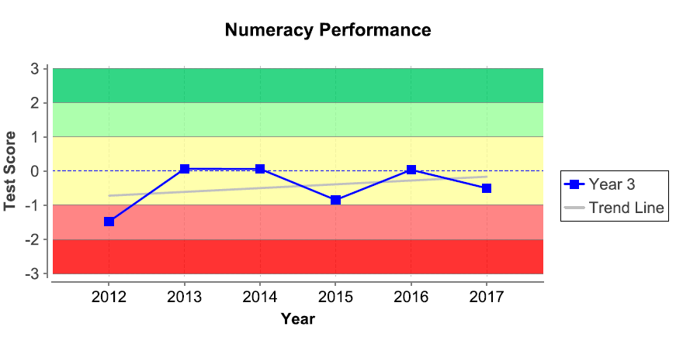

An audit of practice and pedagogy was performed as part of the development of a whole school approach to Numeracy.

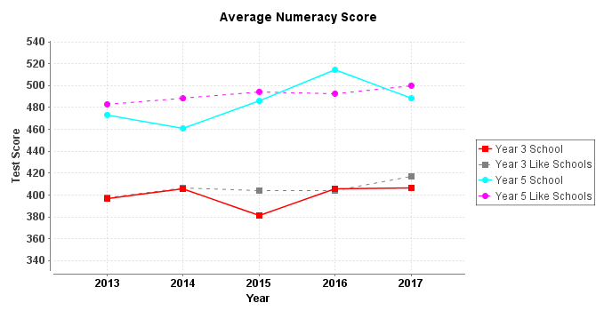

A review of 2017 NAPLAN Numeracy data indicates good progress made from Year 3-5, although achievement is below like schools.

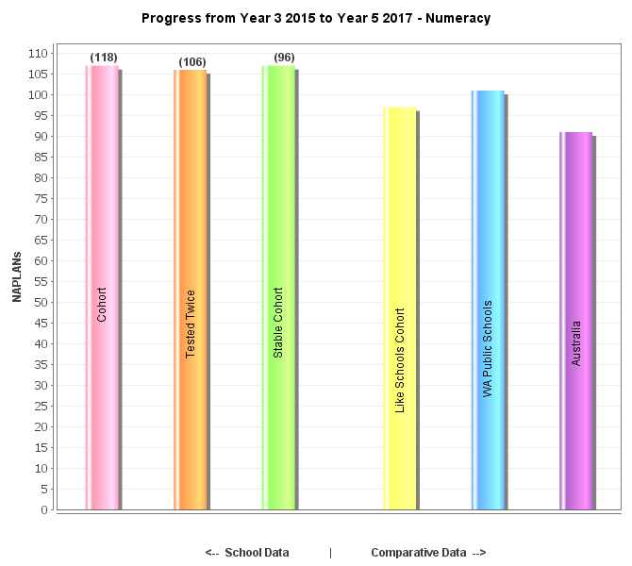

The Whole School Numeracy Overview was developed as part of the School Improvement Process. Its aim was to create a set of common core agreements around the effective teaching of Numeracy and put into place a set of common practices, such as the teaching of fluency games, a working word wall and the implementation of a Numeracy block structure.

**School Data Audit September 2017 – General Findings**

* Year 6 results show not only high achievement in terms of stanines, but a high level of progress; this is particularly evident in Mathematics.
* A high level of achievement is evident in our Year 3 PAT PG (Punctuation and Grammar) results.
* Data analysis reveals a general trend indicating high achieving students are making less progress. Strategies will be considered to address this issue in 2018.
* Cohort tracking indicated a decreasing trend in higher level achievement for Year 3 Reading but a significant upward trend in Numeracy.

**Successful Students**

**Identified School Priorities**

1. Encourage students to be accountable for their learning through the provision of Learning Intentions, success criteria and effective feedback.
2. Encourage students to be enquiring, creative and innovative learners.

**Progress/Achievement**

1. Staff used the DoE Personal and Social Capability Continuum to monitor student progress; this data was reflected in the ABE at reporting time. As part of the Whole School Numeracy plan, staff actively employed the use of WALT (We are learning to) and WILF (what I am looking for) to ensure learning intentions were clear and success criteria evident to students. This approach (as part of the iStar method) can be seen as evident across learning areas.
2. Staff were presented with PL around the Inquiry Approach to learning. A whole school framework (PP-2 and 3-6) was presented to staff for implementation throughout the life of the current business plan.

***Connected Community***

**Identified School Priorities**

1. Articulate and embed the school vision “Be, Think & Grow.”
2. Ensure our learning environment is understood and valued by our community.
3. Nurture positive and genuine relationships through effective communication.

**Progress/Achievement**

1. Signage and branding of the new school vision occurred throughout 2017. A video to explain and promote the vision of ‘Be. Think & Grow’ was made and shared with staff and students. Bletchley Park’s new whole school song of the same title was released and now closes each assembly. The song was written, arranged and recorded by staff and students.
2. Classroom 2 Community was a new initiative that began in 2017. Its intended purpose was:

* To promote parent/community involvement with the school community
* To promote BPPS to the community through parent and community networks
* To formalise our existing parent workshops into a professional programme

Benefits from the programme were seen to be

* Create a network for parents and community members
* Promote strengths of BPPS staff and programmes
* Strengthen BPPS’s community connections
* Keep parents and community members up to date with school plans, policies, programmes and celebrations
* Opportunity for staff to share expertise and develop community relationships and profiles

1. Class Dojo and Seesaw were engaged as methods to keep families up to date with classroom happenings. Facebook is used regularly as a tool for communication. Community surveys are used to determine the majority interest in school occurrences; for example a survey was given to families of prospective Canberra travellers as to their preference for 2018’s tour location.

Financial Summary



Glossary

|  |  |
| --- | --- |
| ICSEA | Index of Community Socio-Educational Advantage |
| P&C | Parents and Citizens |
| AITSL | Australian Institute for Teaching and School Leadership |
| DES | Department Education Service |
| iSTAR | A model for connected practice within classrooms |
| SDERA | School Drug Education and Road Aware |
| NAPLAN | National Assessment Program Literacy and Numeracy |
| WAGSMS | West Australian Government Music Society |
| EAL/D | English as Additional Language or Dialect |
| ICT  WAPPA  EA  BPPS  PL  STEM | Information and Communications Technology  Western Australian Primary Principal’s Association  Education Assistant  Bletchley Park Primary School  Professional Learning  Science, Technology, Engineering and Maths |
|  |  |